# 6. Configuration Management

Configuration Management is the process of establishing and maintaining the regularity or uniformity of a project’s performance and functional attributes with its information throughout its life. It helps to manage all the configurations of the project through five key stages:

1. **Planning:** It deals with how will we record, track, control, and audit the project.
2. **Identification:** It includes functionality, requirements, design requirement and any other specifications of the project.
3. **Controlling:** It must be assessed, approved, and well documented.
4. **Status accounting:** It helps to control the version of the project and also trace out the changes made throughout the project.
5. **Auditing:** It includes all the tests to prove that the product conforms with the configuration requirements. (Wrike, 2019)

Following is the folders that manage the project:

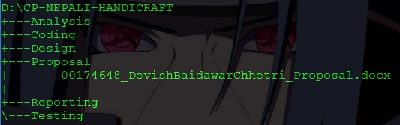

Fig: Project Backup in Internal Drive

External backup is created for any uncertainty of data loss, hardware failure, and other factors.

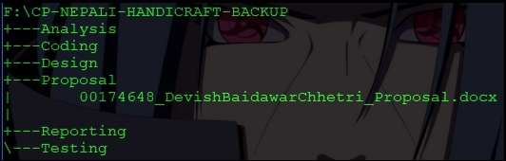

Fig: Project Backup in External Drive

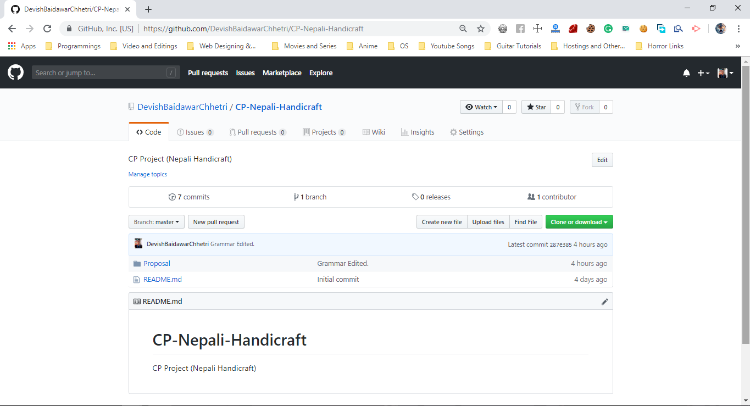

Fig: Screenshot of GitHub’s Repository

**GitHub Profile:** <https://github.com/DevishBaidawarChhetri>

**GitHub Repository URL:** <https://github.com/DevishBaidawarChhetri/CP-Nepali-Handicraft>